10/1/2020 Berkeley - ESPM-1.png

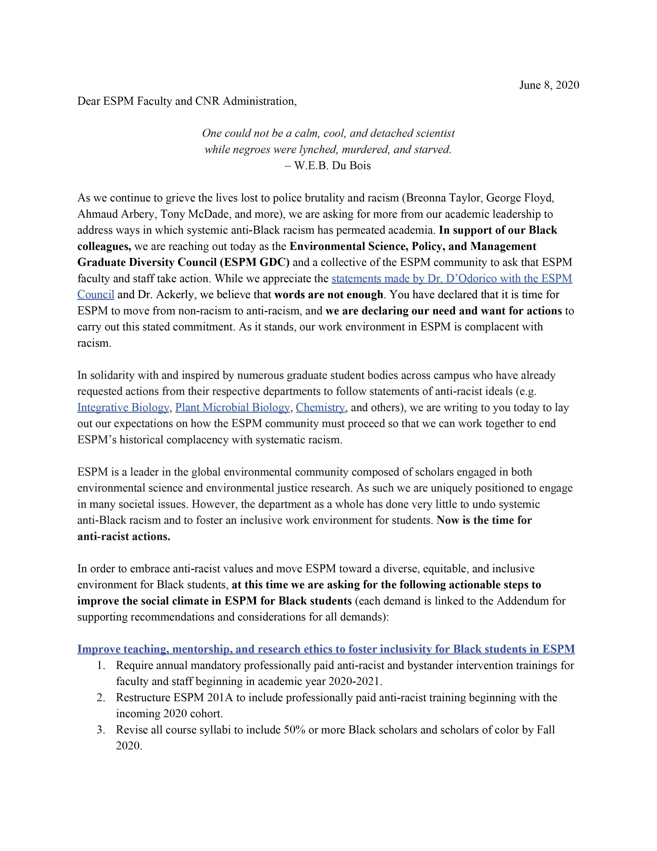

|  |  |
| --- | --- |
| https://drive.google.com/drive/u/1/folders/16POiJDk_8XXhQCDVbIvnURKzg-VdUbRO | 1/1 |

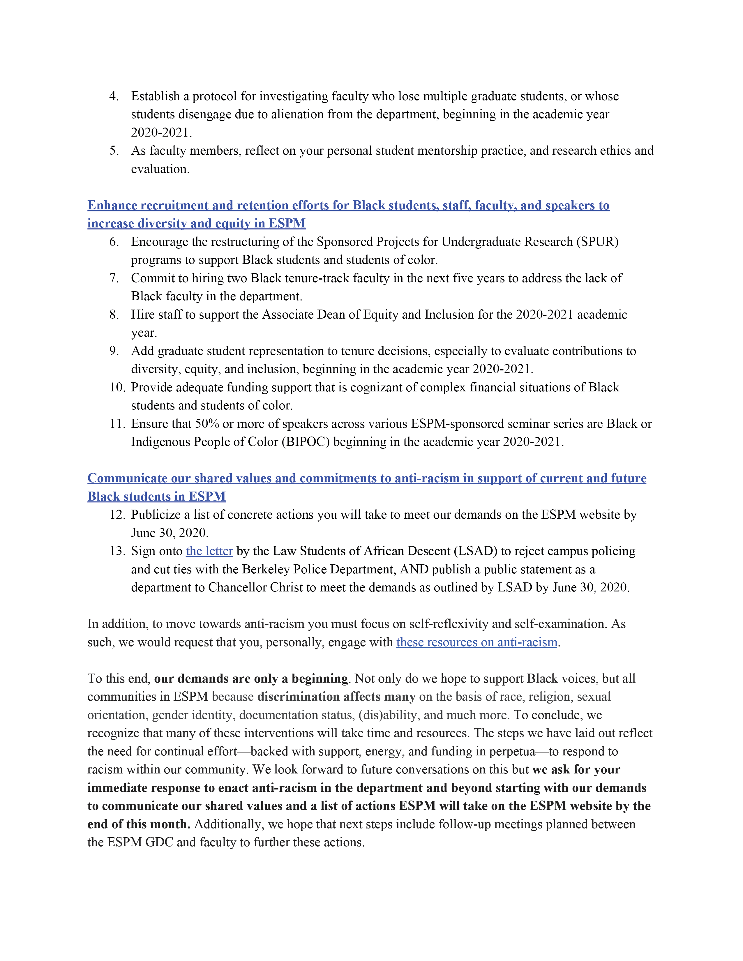

|  |  |
| --- | --- |
| 10/1/2020 | Berkeley - ESPM-2.png |

6. Encourage the restructuring of the Sponsored Projects for Undergraduate Research (SPUR)

8. Hire staff to support the Associate Dean of Equity and Inclusion for the 2020-2021 academic

10. Provide adequate funding support that is cognizant of complex financial situations of Black

Indigenous People of Color (BIPOC) beginning in the academic year 2020-2021.

|  |  |
| --- | --- |
| https://drive.google.com/drive/u/1/folders/16POiJDk_8XXhQCDVbIvnURKzg-VdUbRO | 1/1 |

10/1/2020 Berkeley - ESPM-3.png



|  |  |
| --- | --- |
| https://drive.google.com/drive/u/1/folders/16POiJDk_8XXhQCDVbIvnURKzg-VdUbRO | 1/1 |